**Name: Neha Sharma**

**Roll No. : 54**

**PRN: 1714110448**

**Assignment -1**

**A)Explain different types of optical fibers.**

**Ans :-**

Optical fiber is the technology associated with data transmission using light pulses travelling along with a long fiber which is usually made of plastic or glass. Metal wires are preferred for transmission in optical fiber communication as signals travel with fewer damages.

Single-mode fiber is used for long-distance transmission, while multimode fiber is used for shorter distances. The outer cladding of these fibers needs better protection than metal wires.

**Types of Optical Fibers:-**

The types of optical fibers depend on the refractive index, materials used, and mode of propagation of light.

The classification based on the refractive index is as follows:

**Step Index Fibers**: It consists of a core surrounded by the cladding, which has a single uniform index of refraction.

**Graded Index Fibers:** The refractive index of the optical fiber decreases as the radial distance from the fiber axis increases.

The classification based on the materials used is as follows:

**Plastic Optical Fibers:** The polymethylmethacrylate is used as a core material for the transmission of the light.

**Glass Fibers:** It consists of extremely fine glass fibers.

The classification based on the mode of propagation of light is as follows:

**Single-Mode Fibers**: These fibers are used for long-distance transmission of signals.

**Multimode Fibers**: These fibers are used for short-distance transmission of signals.

The mode of propagation and refractive index of the core is used to form four combination types of optic fibers as follows:

1. Step index-single mode fibers
2. Graded index-Single mode fibers
3. Step index-Multimode fibers
4. Graded index-Multimode fibers

**B)Explain Electromagnetic mode theory of optical propagation.**

**Ans:-**  In order to obtain an improved model for the propagation of light in an optical fiber, elec-tromagnetic wave theory must be considered. The basis for the study of electromagnetic wave propagation is provided by Maxwell’s equations [Ref. 13]. For a medium with zero conductivity these vector relationships may be written in terms of the electric field E, magnetic field H, electric flux density D and magnetic flux density B as the curl equations:

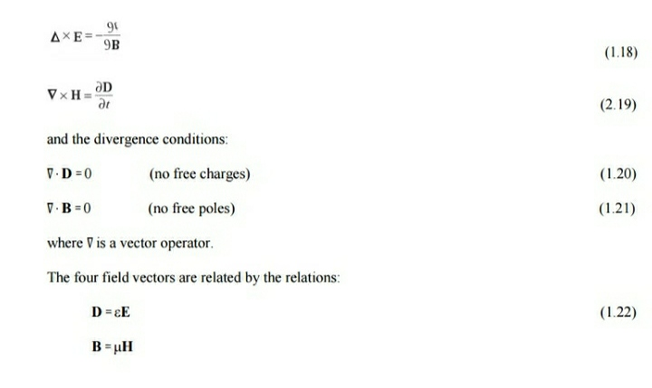

where ε is the dielectric permittivity and μ is the magnetic permeability of the medium. Substituting for D and B and taking the curl of Eqs (1.18) and 1.19) gives:

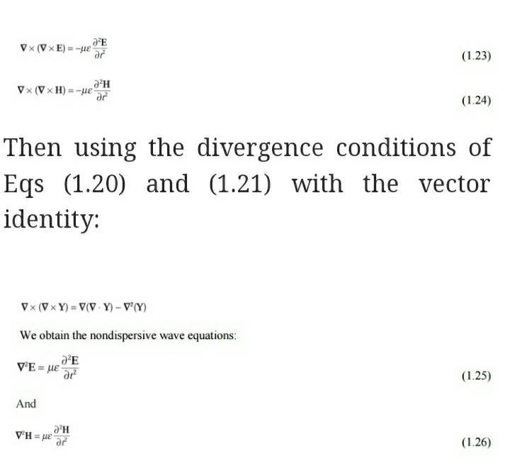

where∇2 is the Laplacian operator. For rectangular Cartesian and cylindrical polar coordinates the above wave equations hold for each component of the field vector, every component satisfying the scalar wave equation

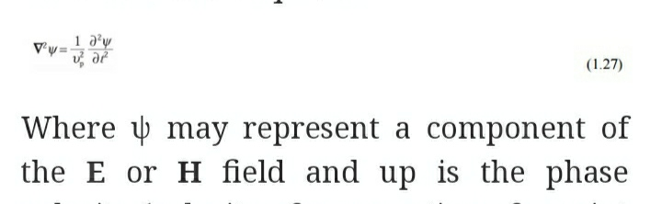

velocity (velocity of propagation of a point of constant phase in the wave) in the dielectric medium. It follows that:

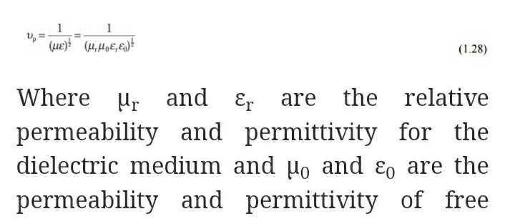 spacecis therefore:

If planar waveguides, described by rectangular Cartesian coordinates (x, y, z), or circular fibers, described by cylindrical polar coordinates (r, φ, z), are considered, then the Laplacian operator takes the form:

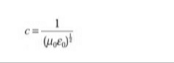

respectively.

Modes in a planar guide

The planar guide is the simplest form of optical waveguide. We may assume it consists of a slab of dielectric with refractive index n1 sandwiched between two regions of lower refractive index n2. In order to obtain an improved model for optical propagation it is useful to consider theinterference of plane wave components within this dielectric waveguide.

The conceptual transition from ray to wave theory may be aided by consideration of a plane monochromatic wave propagating in the direction of the ray path within the guide (see Figure 1.8(a)). As the refractive index within the guide is n1, the optical wavelength in this region is reduced to λ/n1, while the vacuum propagation constant is increased to n1k. When θ is the angle between the wave propagation vector or the equivalent ray and the guide axis, the plane wave can be resolved into two component plane waves propagating in the z and x directions, as shown in Figure

